
Dashboard Design

Team ID | MCA
Project Name | Heart Disease Risk and Patient Health Analysis
Maximum Marks | 5 Marks

The dashboard is designed to present heart disease insights clearly for clinical and population-health teams. It uses KPI cards, simple charts, consistent colours, and clear labels. Interactive filters for Age Group, BMI Category, smoking status, family history, and chest pain type help users quickly identify high-risk patient groups and support preventive-care decisions.
Activity 1: Interactive and visually appealing dashboards
The heart disease Power BI dashboard will follow a clear and intuitive layout, with KPI cards at the top for total patients, heart disease cases, and prevalence rate. Relevant charts such as bar charts, column charts, scatter plots, and donut charts will be used to present risk patterns clearly.
A consistent colour theme will highlight high-risk groups and improve readability. Interactive filters and slicers for Age Group, BMI Category, smoking status, family history, and chest pain type will allow users to explore patient segments. Drill-down features will enable detailed analysis from overall prevalence to specific patient groups. The dashboard will use a responsive design, clear icons, and appropriate visuals to support clinical decision-making.
- Clear and Intuitive Layout: Arrange KPI cards, charts, and filters in a simple structure for easy understanding.
- Use Appropriate Visualizations: Use bar charts, column charts, donut charts, and scatter plots to show heart disease patterns.
- Colour and Theming: Apply consistent colours to highlight heart disease cases and high-risk groups.
- Interactive Filters and Slicers: Add slicers for Age Group, BMI Category, smoking status, family history, and chest pain type.
- Drill-Down Capabilities: Allow users to explore overall heart disease prevalence down to specific patient segments.
- Responsive Design: Ensure the dashboard is easy to use on different screen sizes.
- Custom Visuals and Icons: Use KPI cards, icons, and Power BI Key Influencers visual to make insights clearer.

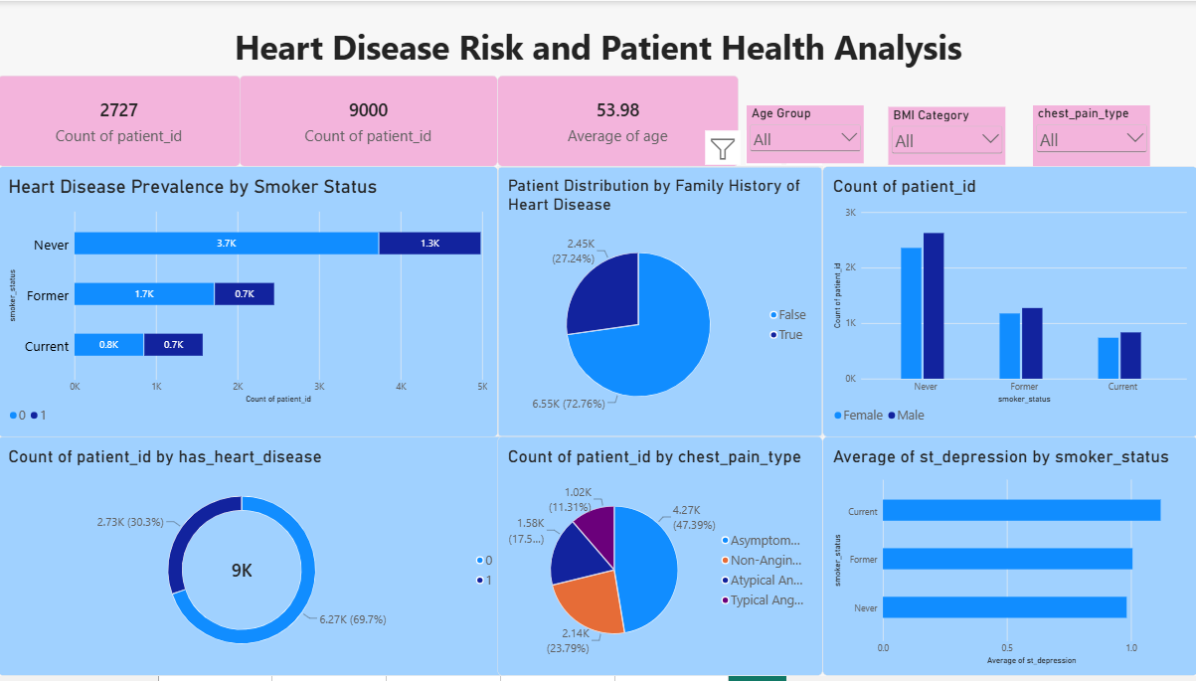
Here are five outcomes from the heart disease dashboard:
- Heart Disease Prevalence: Out of 9,000 patients, 2,727 (30.3%) have heart disease, while 6,273 (69.7%) do not.
- Patient Age Profile: The average patient age is 53.98 years, showing that the dataset mainly represents middle-aged and older adults.
- Smoking Pattern: Patients who have never smoked form the largest group. The dashboard also shows smoking-status differences by gender, with male counts slightly higher across the groups.
- Family History: About 2.45K patients (27.24%) have a family history of heart disease, while 6.55K (72.76%) do not.
- Chest Pain and Stress: Asymptomatic chest pain is the most common category, with approximately 4.27K patients (47.39%). Current smokers have the highest average ST-depression value, suggesting a potentially higher cardiac-risk pattern.

